FOREIGN LANGUAGE DIALOGUE SPOKEN IN CHESS
(EXCERPTED FROM THE SAMUEL FRENCH AMERICAN VERSION ISBN 0 573 68917 6)

This is the text to accompany the recording you will find at http://web.ku.edu/~idea/special/playnames/chess.mp3. A half-speed recording is also provided at http://web.ku.edu/~idea/special/playnames/chessHALFSPEED.mp3

It features the following native speakers of Russian, French, German, and Hungarian in the following order.

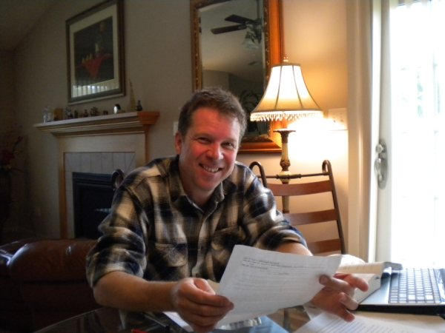Zsolt Mohi
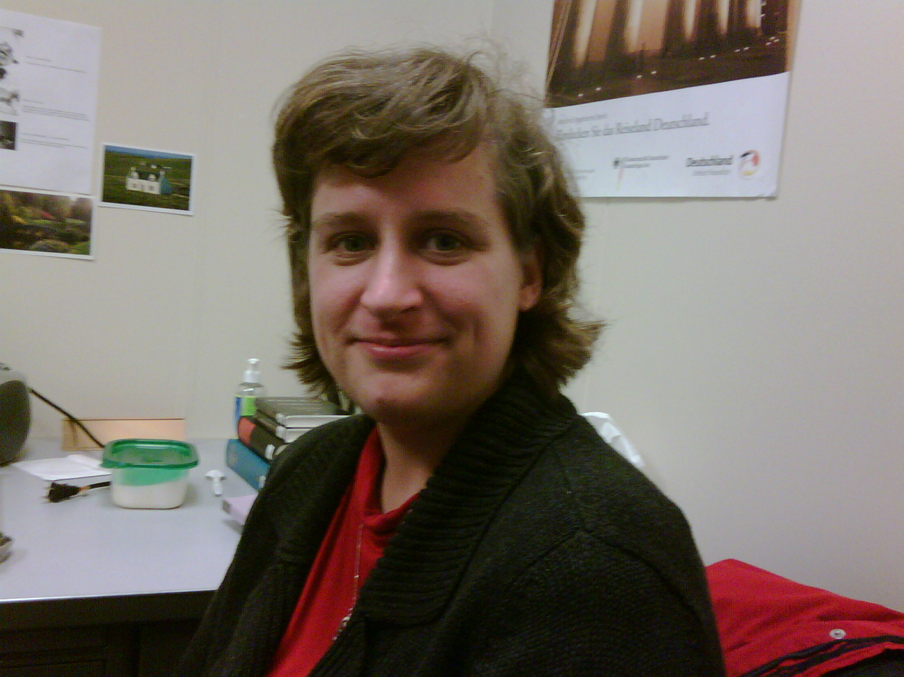Jenny Baisert

- Zsolt Mohi, a native Hungarian, and Ph.D student at the University of Kansas.
- Maia Kipp, a native Russian, and professor emerita in Russian Studies at the University of Kansas.
- Olivia Prouvost-Allen, a native of France, and assistant professor in the French Department, at the University of Kansas.
- Jenny Baisert, a native German, and assistant professor in the German Department at the University of Kansas.

They were recorded by Paul Meier, IDEA’s founder and director, in October, 2009. (Meier’s show-specific CDs for Chess and many other plays and musicals, as well as his dialect instructional books and CDs may be obtained from his website at http://www.paulmeier.com.)

In some cases the native speakers offer emendations. These are shown in square brackets and noted below.

Languages, other than English, spoken in the play:
Hungarian
Russian
French
German

THIS DOCUMENT QUOTES THE TEXT IN THE ORDER IN WHICH IT OCCURS IN THEY PLAY. THE SOUND FILE, ON THE OTHER HAND, PRESENTS THE NATIVE SPEAKERS IN THE FOLLOWING ORDER: HUNGARIAN, RUSSIAN, FRENCH, GERMAN. THE APPROXIMATE TIME AT WHICH THE DIALOGUE OCCURS ON THE RECORDING IS PROVIDED—E.G. (0:08) MEANING ZERO MINUTES AND 8 SECONDS FROM THE BEGINNING.

(0:08)
PROLOGUE: HUNGARIAN NAMES
Prodgsy Street (in Budapest)
Gregor Vassy
Ferenc
Margaret Bridge (in Budapest)
Budapest
Mr. Sergievsky (Szergejevszkij in Hungarian)

(6:52)
RUSSIAN NAMES
Anatoly Sergievsky
Molokov
Nikolai
Moscow
Tolya Sergievsky
Josef
Bangkok
Svetlana (and diminutives)
Rybinsk
Ivan
Budapest
Aeroflot

ACT 1

Scene 1

(11:51)

FRENCH REPORTER. (In French) Mr. Trumper, What is you-? Q’est-ce que vous—

Scene 5

(7:52)
Maia Kipp has kindly expressed the Russian in Cyrillic. It is quoted between curly brackets { }

ANATOLY. (In Russian) What Shtaw {Что?}

ANATOLY. (In Russian) I’m not giving you my—Nee dam {Не дам}

ANATOLY. (In Russian) Is this a joke? EH-tah SHOOT-kah? {Это шутка?}

ANATOLY. (In Russian) Never. Nee-za-SHTAW {Ни за что!}

Scene 8

(8:00)

ANATOLY. (In Russian) How’s the fish? Cock REE-bah? {Как рыба?}

MAN. (In Russian) Excellent. Ot-LEECH-nai-yah. {Отличная}

MAN, (In Russian) Do you have any salt? Ooh vas YEST soil? {У вас есть соль?}

MAN. (In Russian, repeats) Do you have any salt? Ooh vas YEST soil? {У вас есть соль?}

MOLOKOV. (In Russian) I will handle this. Ya EH-teem zai-MOOS {Я этим займусь.}

ANATOLY. (In Russian) Get away from me. Ooh-I-DEE ot S’YOO-dah. (Уйди отсюда.}

MOLOKOV. (In Russian) Your apology? Tee PRAW-zish-eez-vin-YEI-nee-ah? {Ты просишь извинения?}

MOLOKOV. (In Russian) You should get some sleep. Ti-BYEH NAH-de bwee pah-SPAT. {Тебе надо бы поспать.}

MOLOKOV. (In Russian) You can explain this when we get back. Tee m’nyeh ah-b’yas-NEESH pah-TOME, v’gah-STEEN-it-s’yah , {Ты мне объяснишь потом в гостинице.}

ANATOLY. (In Russian) I have nothing to explain. M’nyah N’YEH-che-vo ah-b’yas N’YAT! {Мне нечего объяснять!}

Scene 9

(8:50)

ARBITER. Mr. Sergievsky now leads three points to one. We adjourn until 10 o'clock tomorrow when we resume with the final game of the Bangkok portion of the World Chess Championship.

(Russian) Gaw-spuh-DEEN Sergievsky vee-DY A WT suhSH'YAW-tom tree-ah-DEEN. ZAF-truh VDY' EAH-sit cha-SAWF ooh-TRA su-stai-EET-s'ya fi-NAHL-nee-eh ee-GRA P"YER-voi puh-Ia-VEE-nee MEZH-doo-nahRAWD-nuh-va Cham-pee-uh-NAH-ta SHAKH-mot-nova v'Ban-KOK-yah. {Господин Сергиевский ведёт со счетом три один. Завтра в десять часов утра состоится финальная игра первой половины международного чемпионата шахматного (the preceding two words have to be reversed, otherwise the word order makes it sound like the 18th and early 19th century Russian) в Банкоке.}

(12:07)

(French) Monsieur Sergievsky mene maintenant par trois points a un. Nous arretons le match et il reprendra demain a dix heures pour la final de la partie Bangkok du Tournois d' echecs mondial.

(12:38)

(German) Herr Sergievsky fuhrt jetzt drei zu eims. Wir Brechen ab bis zehn uhr morgen wenn wir mit dem letzten spiel von dem Bangkok weitermachen werden.

[(German) Herr Sergievsky führt jetzt drei zu eins. Wir Brechen ab bis zehn uhr morgen wenn wir mit dem letzten spiel in Bangkok weitermachen werden.]

(9:50)

NIKOLAI. (In Russian.) Come on, I think we've all deserved a drink. Sta-REEK, NAH-da pah-ee-TEE VWEE-pit. {Старик, надо пойти выпить.}

ACT 2

Scene 1

(0:39)

CHOIR. (In Hungarian)
MINDEN V AGY AM VISSZASZALL
ODA HOL AZ EDES HAZAM VAR
ZOLD ERDO VIRAGOS RET
SHAL A REGL REGL HAZAM MEG
TUDOM EGYSZER VISSZETEREK EN
VISSZA MEG, VISSZA MEG,
VISSZA MEG, VISSZA MEG,
BUJDOSASOM VEGET ER
S'ITT V AGOYOK UJRA
SZEP HAZAMBAN EN

HUNGARIAN WOMAN. (In Hungarian, to FLORENCE.) Have you heard them sing in church? Hallotiad oket epy templomban enokelai?

CHOIR. (Starts again, under dialogue.)
NEM CSABIT A MESSZESEG
NEM CSABIT A NAGUYVLLAG
EIMULT MINEN KISERTESEM MAR
TUDOM ITIHON V AGYOK VEGRE MAR
VEGREMAR
BUJDOAASOM BEGET ERT
S TIT V AGYOK VEGRE
SZEP HAZAMBAN EN

And following are Zsolt Mohi’s emendations and corrections, in correctly spelled and accented Hungarian:

[Minden vágyam visszaszáll
Oda, hol az édes hazám vár.
Zöld erdő, virágos rét,
S áll a régi házam még.
Tudom, egyszer visszatérek én,
Vissza még, vissza még,
Vissza még, vissza még.
Bujdosásom véget ér,
S itt vagyok újra
Szép hazámban én.]

HUNGARIAN WOMAN. (In Hungarian, to FLORENCE.) Can you hear the melody from the church? [Hallod a dalt a templomból?]

[Nem csábít a messzeség,
Nem csábít a nagyvilág,
Elmúlt minden kísértésem már.
Tudom, itthon vagyok végre már,
Vérge már.
Bujdosásom véget ért,
S itt vagyok vérge
Szép hazámban én.]

Act 2, Scene 1

(10:00)

ANATOLY. Josef! (To BEN and PETE.) They are old friends from my town. (In Russian, he greets them, then:) What are you doing here? Shtaw vivee toot D' Y ALE-ae-a-tyeh? {Что вы тут делаете?}

ANATOLY. (In Russian.) This is a great surprise! Ka-KOY s'yurPREES! Which hotel are you in? Fka-KOY vivee gahSTEEN-it-s'yah?{Какой сюрприз! В какой вы гостинице?}

1ST RUSSIAN. (In Russian.) How are you? Noo, COCK tee? {Ну, как ты?} It's wonderful to see you! Rad ti-BYAH VEE-dyet! {Рад тебя видеть.} We were just talking about you! Ah mwee TOIL-ka shte guhvah-REEL-oe ah ti-BYEH!{мы только что говорили о тебе.} He looks good! Awh priKRAS-na VWEE-gli-dit! {Он прекрасно выглядит!}
2ND RUSSIAN. (In Russian.) We were hoping we'd run into you, Anatoly. Mwee TOCK oe DOO-mah-lee shte FSTRAY-tim ti-BYAH. {Мы только думали, что встретим тебя.} How are you? Cock ZHEEZN muh-la-DAI-a? {Как жизнь молодая?} You haven't changed. Tee sef-S'YEM nee eez-men-N' EEL-s'ye. {Ты совсем не изменился.} We have tickets for your match. Ah ooh nas YEST bi/-YET-oe nah match. {А у нас есть билеты на матч.”

Scene 4

(10:40)

ALEXI. (In Russian.) Seriously, you've never played better. Si-ree-A WZ-na, tee nee-tog-DAH tak khuh-rah-shaw nee au-GRAL. {Серьёзно, ты никогда так хорошо не играл.}

ANATOLY. (To FLORENCE.) Alexi says this afternoon was the best he'd ever seen me play.
3RD RUSSIAN. (In Russian.) You're in good form, no worse than in Bangkok. Tee FFORM-ya, nee KHOO-zhe chem v Ban-COCK-ya. {Ты в форме, не хуже, чем в Банкоке.}
ANATOLY. (To FLORENCE.) That I've lost nothing since Bangkok.
FLORENCE. Why should you have-?
2ND RUSSIAN. (In Russian.) It's only a matter of days before you finish with the American. Ooh-VYAREan, CHI-raz PAH-roo DNYEI tee ah-bi-GRAI-esh Ahmer-i-KAN-sa. {Уверен, что через пару дней, ты обыграешь американца.}
ANATOLY. (In Russian.) We can hope. BOO-dyem nah-DYEI-it-s'ya. {Будем надеяться,} (To FLORENCE.) That I could be finished with Freddie in a few days.
1ST RUSSIAN. (In Russian, to FLORENCE.) Thank you. Spah-SEE-ba. {Спасибо}.

Scene 7

(11:00)

ARBITER. (Over a speaker.) Mr. Trumper has won the nineteenth game. The score is now Mr. Sergievsky 5, Mr. Trumper 5.

(12:19)

(French) Monsieur Trumper a gagne le dix-neuviene jeu. Ils sont maintenant a egalite cinq a cinq.

(Russian) Gah-spa-DEEN TRAHM-per VWEE-gral d'ye-vitNAHD-sit-ooh- you PAR-too-yoo. Ssh'yawt teh-P'YEIR p'yat-p'yat. . {Господин Трампер выиграл девятнадцатую партию. Cчёт теперь пять пять.}

(12:33)

(German) Herr Trumper hat dad neunzehnte spiel gewonnen. Das ergebnis ist jatzt: Herr Sergievsky funf punkte, Herr Trumperfunfpunkte.

[(German) Herr Trumper hat das neunzehnte spiel gewonnen. Das ergebnis ist jetzt: Herr Sergievsky hat jetzt fünf punkte, Herr Trumper hat fünfpunkte. OR Herr Trumper hat das neunzehnte spiel gewonnen. Das ergebnis ist jetzt: Herr Sergievsky hat jetzt fünf punkte, Herr Trumper der gleichstand.]

Scene 8

(11:10)

MOLOKOV. (In Russian.) Greeting from your brother. Ti-BYEN pree-UYET ot BRAH-to. {Тебе привет от брата.}

MOLOKOV. (In Russian.) What are you doing? Shtaw tee D'Y ALE-a-ish? {Что ты делаешь?}

NIKOLAI. (In Russian.) If you walk away like that again, you'll get it from me. YEI-slee yee-SHOW ras tee tak ooh-ee-D' Y A WSH, pah-LOO-chish ooh nain- Y AH. {Если ещё раз такое сделаешь, получишь от меня!}

ANATOLY. (In Russian, to NIKOLAI.) If you do, I'll ... Tee SHTAW ska-ZAL, da ya tib-YAH ... {Ты что сказал? Да, я тебя....}
NIKOLAI. (In Russian, to ANATOLY.) Fuck your mother. H'YAWP tvai-OOH mat'l. {Ёп твою мать!}

Scene 10

(3:22)

Zsolt Mohi’s emendations and corrections are provided in square brackets.

FATHER. (In Hungarian.) It is you. Ez te vagy. [Hát te vagy az!]

(FLORENCE turns to MOLOKOV.)

MOLOKOV. He recognizes you.
FATHER. (In Hungarian.) Her mother had those eyes. Anyja szemeit orokoite. [Az anyja szemét örökölte.]

MOLOKOV. You have your mother's eyes.
FATHER. (In Hungarian.) My mouth, when I was your age. Az enszam, a te korodban. [Az én szám, amikor ilyen idős voltam.]

MOLOKOV. His mouth. When he was younger.

MOLOKOV. (In Hungarian.) She's seen pictures, but- Feynke poket is tott, de [Fényképeket is látott, de…]

MOLOKOV. (In Hungarian.) If you are her father, why didn't you try to find her? Ha te vadj az apam miertnem kerestel engem? [Ha te vagy az apja, miért nem kerested őt?]

(AT this point on the recording, Maia Kipp, our Russian expert, speaks Molokov’s two Hungarian lines, to convey what Russian-accented Hungarian might sound like. She does not speak Hungarian in everyday life, but was coached in these two lines by Zsolt Mohi.)

FATHER. (In Hungarian.) Ask the Russian. Kerdezd meg az orosztol. [Az orosztól kérdezd!]

FATHER. (In Hungarian.) Go, go, leave us alone. Menyj! Haggyai minket egyedul. [Menj, hagyj minket magunkra.]

SLEEP MY LITTLE GIRL
KEEP YOUR EYES CLOSED
ON THE WINGS OF SWEET DREAM
FLY UNDISTURBED
ON YOUR DADDY'S STRONG HAND

ALUDJ KICSI LANYKAM
HUNYD BE SZEMECSKED
ALMODEDES SZARNYAN
SUHANJ KONNYEDEN
APUKAD EROS KEZEN

[Aludj kicsi lánykám,
Hunyd be szemecskédet,
Álmod édes szárnyán
Suhanj könnyedén,
Apukád erős kezén.]

YOUR PILLOW IS ASLEEP
SOON THE LAMP WILL SLEEP
FLY MY LITTLE GIRL
ON THE BLUE SKY OF DREAM
ON YOUR DADDY'S STRONG HAND

ELALUDT A PARRIAD
ELALSZIK A FENY
SUHANJ KICSI LANYKAM
ALMOD KEK EGEN
APUKAD EROS KEZEN

[Elaludt a párnád,
Kialszik a fény.
Suhanj kicsi lánykám
Álmod kék egén,
Apukád erős kezén.]

FLORENCE. (Closing her eyes.) Father?
FATHER. (In Hungarian.) Father. Apuked. [Apukád]
FLORENCE. (In Hungarian.) Father. Apuked. [Apukád] (In English.) That means "Father," doesn't it? (Beat.) I remember that. (She kneels at his feet; he continues singing, she hums.)

YOUR LITTLE TOYS
ARE ASLEEP AROUND YOU
SLEEP MY LITTLE ANGEL
SLEEP GENTLY LULLED
BY YOUR DADDY'S STRONG HAND

JATEKAID ARVAN
VARNAK SZERTESZET
EGYETIEN BOGARKAM
ALUDJ KONNYEDEN
APUKAD EROS KEZEN

[Játékaid árván
Várnak szerteszét.
Egyetlen bogárkám,
Aludj könnyedén,
Apukád erős kezén.]

Scene 12

(11:40)

MAN. (In Russian.) You can board if you want: it won't be long. Kha-TEET-ye, MAW-zhe-tyeh ee-TEE fsam-ol-YAWT. SKAW-ra pah-l'yet-TEEM. {Хотите, можете в самолёт. Скоро полетим.}

SVETLANA. (In Russian.) Yes? Da? {Да?}

Document prepared by Paul Meier
©2009 The International Dialects of English Archive (IDEA)
http://web.ku.edu/~idea

